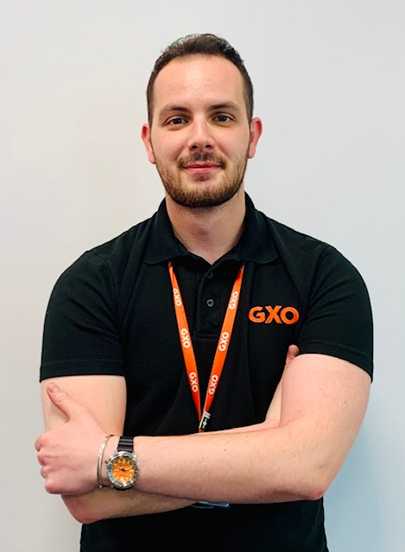
EMEG Case Study,
Ed Gould
I am an Operations Manager at GXO Nestle East Midlands Gateway (EMG) in the UK. I started at GXO in February 2020, just as the Covid-19 pandemic began. Fast forward 2 years and 8 months and I can honestly say I have never looked back.
Background:
I grew up near to the EMG site where I am based in the Midlands. I am the son of two School Teachers, and I have always vowed to do them proud and support my younger brother who is on the autistic spectrum. I studied History at University and graduated in summer 2015. Like many people, I never knew what career path I was going to pursue growing up. I was not confident, but I had to start somewhere. I began in the hospitality industry. I worked hard, showing discipline and determination and was able to progress into a management role within a couple of years. I worked in this sector for just over 4 years and enjoyed working with my team. Then, sadly, me and my whole team were made redundant. After the initial shock I took a leap of faith and went for a career change.
Starting at GXO:
I applied for the role of Digital Partner (Operative) at GXO EMG. I did not know what to expect. I had never worked in supply chain, and very little knowledge of the logistics process. I was asked to attend an Assessment Day, which included team building exercises, a tour of the site, problem solving and an interview. A week later I received an email saying I had been successful and had been offered the job, which included working towards a Level 3 Apprenticeship in Fast Moving Consumer Goods and Supply Chain. I could not believe it.
This was a whole new experience, a new start on a new site I knew nothing about, but I was determined as ever make my mark. The operative role gave me many new skills, such as MHE training, including Reach Truck, Counterbalance and PPT. I loved it. I was trained on all the Inbound and Outbound processes such as loading, unloading trailers, marshalling, and picking stock ready for distribution to all major supermarkets in the UK as well as the rest of the world. I was made to feel welcome, supported and challenged to become a better version of myself. I began building strong working relationships with both my team and my peers, and soon found myself put forward for additional training. I took everything GXO could offer me. Fire Marshall and First Aid Training, Mental Health Awareness and Empowering Productivity to name just a few. I was growing in confidence. I was learning new skills and experiences and was enjoying every minute of it.
Progression:
A couple of months into the role, I was put forward to become a Trainer. This role involved the training of new starters on site and integrating them into the Operations team. I took a great deal of pride in this. Not only was I responsible for instilling safe and standard practices in all new starters, but I was tasked with being one of the first people to introduce them to their new working environment. Starting a new job can be terrifying, with new names, new faces and new processes. I wanted to make every newcomer feel as welcome and valued as I had felt. Everyone is different, they learn differently, at different speeds and come from a whole range of backgrounds, skillsets, countries, languages, and environments. GXO is strong example of diversity, and I am proud to be a part of that.
As a Trainer, I carried out my role for several months before applying for the role of Shadow Enabler (Team Leader) at EMG. I wanted to move into a role that allowed me to exercise my management skills obtained from my hospitality experience. I applied, making sure to highlight all the specific skills that I had learnt since starting with GXO and ensured my CV was up to date. I was successful and jumped at the opportunity to assist in leading my shift. I could not be happier, the hard work I had put into learning a new job in a completely new sector had paid off.
Leadership:
Everyone is different; you realise in a leadership role is that everyone needs managing as an individual but also collectively as a team. You are tasked with steering the ship and overcoming challenges by utilising the skills of your team in the most efficient manner. I completed two seasonal peaks at Christmas and Easter. The amount of Quality Street and Kit Kats one sees fly in and out of the site during these periods is mind blowing. The operatives are without a doubt a key instrument in this machine we call ‘supply chain’. Without them, Christmas and Easter would be a lot less tasty! As a Team Leader, I began building up a working relationship with the customer, which at EMG is Nestle. You learn what the requirements and service level agreements are between the site and customer and work with them to deliver results whilst hitting those important key performance indicators or KPIs. This brings added responsibility, accountability and pressure, but one of the most satisfying feelings is having a day where you are non-stop, resolving issues, problem solving, attending meetings, completing training and at the end of it, no matter how tough it has been, knowing you achieved it with your team by your side. GXO instils this in its employees from day one and it is critical to our success.
I am a very motivated person and have always tried to do the best. Working at GXO has only magnified that drive. I have been pushed, not forcefully I might add, to learn new things and go outside of my comfort zone. This is something everyone fears, whether it be speaking in front of large groups of people or delivering a project from end to end. The unknown will likely scare you, may hold you back, but ultimately without it you will not grow and achieve your full potential. If you never take a chance, you will never know the outcome. Had I not taken the chance and applied for a role in a completely new sector after being made redundant, I would not be where I am today.
More progression:
Back to the Operation! I spent approximately six months in my role of Team Leader. I wanted to learn more and achieve more of which I knew I was capable. A job role came up at EMG for the role of Light Goods Specialist (Shift Manager). I drafted a cover letter; this was going to be my next big step, I was convinced. I attended the interview, all prepared for the questions, suited up and ready to go. Unfortunately, I was unsuccessful. But I did not let this get me down. I requested feedback from the interviewing Managers and was told that my interview was good, but operationally my site experience working with Light Goods and the system itself was limited, with which I completely agreed. I had been working at EMG less than a year and the jump to a Shift Manager role so soon was ambitious, but more importantly it showed I was determined. It is here that I want to highlight the importance of failure.
Without failure you cannot learn, you cannot digest constructive criticism which is necessary to improve your skills and become better in your role. I knew I had more to learn and so went back to the drawing board. During the next several months, I honed my skills as a Team Leader and stayed close to my Shift Managers, whose roles I stepped up to in their absence. I learnt the Main DC Inbound and Outbound functions in greater depth, the systems and the standard operating procedures that drove the operation through several peak seasons. Approximately six months later, a Shift Manager role presented itself. I applied and found myself on a six-month secondment as a Digital Enabler (Shift Manager) in the Main DC. I had reached my short-term goal! I assumed more responsibility on the shop floor, communicating with the customer at a closer level and prioritising workloads by directing my team with efficiency and a positive attitude. Since then, I have progressed to Operations Manager at the start of 2022. I would be lying if I said any management role is easy. It is challenging yet rewarding. I would encourage anyone who wants to progress into leadership to rise to the occasion.
Today
My journey at GXO has been one of success, failure, growth, and a long winding road of experience. I have come a long way, learning a lot and making some great friends. But my journey is not over yet. So, my advice if any would be this: Be patient - there is always more to learn – never get too comfortable – take pride in your work - act with integrity – and keep moving forward. I have always tried to surround myself with positive people, both in the workplace and out. Find them, feed off their knowledge and use it to achieve your full potential. I am proud of my journey, if you are reading this, I hope you are too – here is to your future career at GXO.

