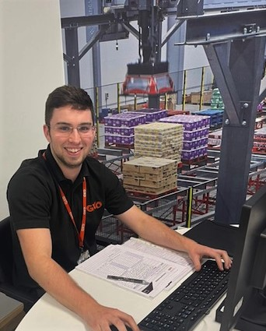
EMEG area Case Study, Max Cowlishaw
My career path into logistics:
After completing my A-Levels I was working as a lifeguard while I was looking for an apprenticeship. I joined GXO’s apprenticeship scheme in 2020 during the testing phase of the site. I worked as a normal operator helping with operational training as a step up for new inductees onto site, as I continued to work on my apprenticeship. In January 2021 the site was looking for another full-time operational trainer. With my experience and training, I applied and was successful for the role.

My day-to-day work:
I work on average 45 hours a week from Monday to Friday, providing training on all types of warehouse vehicles for our site as well as operational training across all work areas. I’m involved with day-to-day health and safety matters to make sure the site is maintaining a zero-accident policy. I liaise with my manager and help provide inductions for the site to welcome new employees to the business in a positive way. I work closely with the Shift managers to provide operational training and upskilling training to members of their shift.

Development and training:
I came to GXO with 8 GCSE’s and 3 A-levels. The company has given me a wide range of development opportunities, in my time here. I’ve completed my IOSH management course. I’m also a fully qualified first aider and fire marshal. I’m a fully qualified MHE (Material Handling Equipment) instructor under three accrediting boards. ITSSAR, AITT and IPAF. I’m able to conduct Drug and Alcohol tests for my site as well as complete investigations. I'm still currently doing my Level 3 FMCG (fast moving consumer goods apprenticeship).
I’m a very driven person which has helped me to get to my position within logistics. I work well with people which allows me to meet different peoples training needs. Everyone learns in different ways so it’s important to identify how people learn increase their knowledge and skills as smoothly as possible. I’m a very organized person which allows me to conduct my role efficiently. I keep all my important MHE documents in order and make sure to update my plan so everyone within the business can see what’s been conducted through the week.

Why is logistics a great sector to work in?
For me logistics is a fantastic area of work to get into, when I first joined, I didn’t realise how many different skills and training I would learn during my time with GXO. There are a range of different channels of work you can specify into whichever suit you best. It constantly everchanging so you’ll be learning new things every day you come to work. The site I currently work is the flagship site for the UK. Its almost fully automated which has increased accuracy and efficiency.

