YEAR 7
Activities and learning:
- in PSCHE time are in black
- in assemblies are in green
- in other curriculum subjects are in red
- collapsed timetable days and extra-curricular are in blue

 | CAREERS & WORK-RELATED LEARNING | GATSBY  BM | CDI  AoL
Each & Every | Autumn Term  - Induction Day 3 – aspirational careers assembly by the Head teacher and Head of Year with 2 hours of follow up materials in tutor time.  - ‘Dream Big’ (4 lessons) – students are encouraged to think about their ideal future and to aim high! Using their oracy skills they prepare a presentation to the class about their life 20 years from now. They are encouraged to describe their dream job and why they aspire to it.  - ‘I love my job’ assembly by a volunteer with tutorial follow up  - Introduction to the Careers and Work-Related Learning Co-ordinator and resource library.  - Speed networking event that gives the students to meet volunteers from a range of sectors. Volunteers answer questions developed by students working in small groups. Volunteers picked to challenge gender stereotypes. Focus on employability skills.  Spring Term  - National Careers Week – students experience a range of subject related employer visits  - Science week – activities within Science lessons that focus on relating Science to issues in the wider world.  - ‘I love my job’ assembly and tutorial follow up  - ‘Why do we work’ presented by Job Centre Plus  Summer Term  - ‘Jobs and more Jobs’ (2 lessons) – students complete a quiz with follow up discussion to find out about a range of jobs, focusing on salaries, minimum wage and key skills needed to be successful in these jobs.  - ‘Which career is right for me?’ (2 lessons) – students complete a diagnostic questionnaire to find out which careers match with their interests. Students then further research a career of their choice using the school’s Careers Library or in an ICT suite. Students are shown how to use and Career Research Platforms including CareerPilot and Unifrog.  - ‘I love my job’ assembly and tutorial follow up  - English - Year students 7 write letters to Year 6 students about managing transition  - Maths - Financial literacy project | 3  3  2  2  3, 4 & 5  4 & 5  4  2  2  2  2  4  4 | 1 – 3  11  5 – 7  4  4 – 7  7  7  5 – 7  5  7  1 – 3  7  5 – 7  11  13
Additional | - 1:1 interviews with the Careers and Work Related Learning Co-ordinator (open door policy & Head of Year referral)  - Students complete written applications to apply for leadership roles within school. | 8  3 | 10 & 14  11 & 12

YEAR 8
 | CAREERS & WORK-RELATED LEARNING | GATSBY  BM | CDI  AoL
Each & Every | Autumn  - ‘I love my job’ assembly and tutorial follow up  - ‘Train the right way’ (2 lessons) – students are introduced to the concept of apprenticeships and provided with information about how they work. Students then debate the advantages and disadvantages of apprenticeships compared to attending university.  Spring Term  - National Careers Week – students experience a number of ‘where my subject has taken me’ talks  - I love my job’ assembly and tutorial follow up  - ‘Employability skills’ (3 lessons) – students are introduced to the concept of employability skills and given the opportunity to assess themselves against the eight skills as well as practice answering general employability skills style interview questions.  - Creative Take Over – Run by the Real Ideas Organisation, this is a day where students get the opportunity to work in teams and apply their creativity to the world of work.  - Ready, Steady, Cook – immersive experience led by a professional chef.  - ‘Maths in Business’ morning  Summer Term  - ‘I love my job’ assembly and tutorial follow up  - Real Game (10 lessons)  Dreams – importance of aspirations  Job Research  Money, Spending & Personal Belonging  Jobs & Our Community  Transferable Skills  Stereotyping  Job Loss & CVs  Local Government Citizenship  - English- Teaching the importance of editing work and explaining that editing is a job role and how editing contributes to career roles in occupational areas, such as journalism. | 5  7  4 & 5  5  5  5  4  2  4 | 5 – 7  14  4 & 7  5 – 7  11  11 & 12  7, 11 & 12  4 – 7  5 – 7  7
Additional | - Students complete written applications to apply for leadership roles within school.  - Women into STEM Day  - 1:1 interviews with the Careers and Work Related Learning Co-ordinator (open door policy & Head of Year referral) | 3  4  8 | 11 & 12  8  10 & 14

YEAR 9
 | CAREERS & WORK-RELATED LEARNING | GATSBY  BM | CDI  AoL
Each & Every | Autumn Term  - ‘Employability Skills (3 lessons) – spotlight on problem solving.’ Students realise the importance of this high-level skill in the workplace and break down how to become better at problem solving.  - Take Your Child to Work Day  - ‘I love my job’ assembly and tutorial follow up  - Students examine diversity and discrimination, particularly gender stereotypes. They complete research to investigate the different routes to employment e.g. different qualification pathways, apprenticeships and higher education.  Spring Term  - ‘I love my job’ assembly and tutorial follow up  - ‘Where this subject can take you’ presentations in individual subject lessons as a part of the build up to Options Evening.  - 1:1 options interview with a member of SLT and parents  - Options Support through tutorial lessons and Options Evening  - Careers and Labour Market Information assembly  - Post 16/18 Experience Day – students choose to spend a day at X University or Y College.  Summer Term  - Starting to think about work experience  - ‘I love my job’ assembly and tutorial follow up  - English-Competitions ran for students within poetry and creative writing.  - Exeter University presentation to introduce the Exeter Scholars programme assembly to students. Eligible students encouraged to apply to the Easter Residential and the Exeter Scholars programme that provides activities and mentoring to find out more about higher education and university. | 5  2  3  7  2  4  2  7  6  2  4  7 | 11  4 – 7  5 – 7  8  5 – 7  4 & 7  14  14  7  14  10 & 11  5 – 7  11  12
Additional | - Post-14 Options Evening open to all students and their parents (including LMI presentation to parents)  - Duke of Edinburgh Scheme  - Exeter Scholars Programme - (15 students 6 x sessions led by undergraduates and a visit to the Exeter University Campus with their parents).  - Army Corps Engagement Team – (40 students experience real life army activities such as infantry command tasks and bomb disposal robotics)  - Students complete written applications to apply for leadership roles within school. | 2  3  7  2 & 5  3 | 14  11 & 12  12, 14 & 15  4 – 7, 11 & 12  11 &12

YEAR 10
 | CAREERS & WORK-RELATED LEARNING | GATSBY  BM | CDI  AoL
Each & Every | Autumn Term  - ‘Opportunities in Cornwall Day’ – students visit a carousel of employers, undertake mini work-related tasks and listen to the employer talk about their job with opportunities for questions.  - The Skills Show – students attend a careers fair featuring a wide variety of local and national employers along with higher education providers.  - ‘I love my job’ assembly and tutorial follow up  Spring Term  - ‘Post 16 – what is right for me?’ – Using Startprofile.com students explore Post 16 options and complete diagnostics to personalise which pathway best suits their interests and skills.  - Interview techniques: being ready for the world of work, different types of careers, changing world of work and what you can and can't be asked in an interview.  - Writing a Curriculum Vitae: creating a working document that can be updated in year 11  Summer Term  - Preparation for work experience (4 assemblies)  - Follow up preparation work (4 lessons) covering topics such as health and safety, safeguarding and expectations on work experience. What you do in a range of situations on work experience  - 1 week of work experience  - Work experience debrief and thanking employers (1 lesson)  - English - Macbeth – directing a scene. Giving clear instructions and then justifying choices.  - English - An Inspector Calls. Exploration of how the workforce are treated and workers’ rights. In addition, a discussion of the role of an inspector, within the police force and how his power affords him status and trust. | 2, 3 & 5  2, 3 & 5  2  7  6  6  6  6  4  4 | 4 – 7  4 – 7  5 – 7  14 & 15  16  16  10  9  4 – 7 & 11  7  7
Additional | - Peer Mentors – help manage the transition of Y6 students to Y7 (28 students over two terms)  - Post-16 Options Evening open to all students and their parents.  - Duke of Edinburgh Scheme  - Exeter Scholars Programme - (15 students 4 x sessions led by undergraduates)  - Extended work experience for all students on alternative provision.  - Links with X College of Art for students taking art and textiles at GCSE.  - Business visits for GCSE Business and BTEC Enterprise groups  - Students complete written applications to apply for leadership roles within school. | 3  7  3  7  6  4  4  3 | 11 & 12  14 & 15  11 & 12  11, 12 &14  14  6 & 7  11 & 12

YEAR 11
 | CAREERS & WORK-RELATED LEARNING | GATSBY  BM | CDI  AoL
Each & Every | Autumn Term  - CV updating  - Students complete Action Plans  - Careers Circus (4 lessons) – students carousel around 6th Form, interview techniques with the Rotary Club, Career Pilot and National Careers Service delivered by the Careers and Work-Related learning Co-ordinator.  - One-to-one careers interviews (as many as students’ need)  - Employability skills – self assessment and development of an action plan  - Labour Market information – looking at county and national statistics and trends  - Letters of application  - Series of Post 16 assemblies (X, Y, Z colleges and at least one apprenticeship providers).  - Drop in / information sessions.  - Post-16 Experience Day – students experience a day in the life of a Y12 student, either at the 6th Form or other establishments such as St Austell and Plymouth City College. Some students have a day with apprenticeship providers.  - Mock Interviews with employers – all students prepare and take part in a 10-minute mock interview with feedback.  Spring Term  - Talks by local colleges  - National Citizenship Service – introduction to volunteering opportunities with follow up workshops.  - ASK Apprenticeships workshops  Summer Term  - Revision Techniques  - Leavers on-line survey to help evaluate impact of CEIAG  - Parents on-line survey to help evaluate impact of CEIAG | 7  7  8  2  7  7  7  2  7  1  1 | 16  16  14 & 16  14 - 17  11  7  16  14  14 & 15  11 & 16  14  11 & 12  14
Additional | - Post-16 Options Evening open to all students and their parents  - Parents’ Careers surgery (January)  - Exeter Scholars Programme (15 students 4 x sessions led by undergraduates)  - Duke of Edinburgh Scheme - develops employability and personal skills as well as work experience  - National Citizen Service (NCS) scheme in summer holidays  - Y11 SEND transition visits to colleges  - Students complete written applications to apply for leadership roles within school.  - Focus group research – Enterprise Advisers to meet representative groups of Year 11 and students to discuss their perceptions of the CEIAG they have received from Year 7 to 11/13 | 7  8  7  3  3  3  3  1 | 14 & 15  14 – 17  11, 12 & 14  11 & 12  14 &15  11 & 12

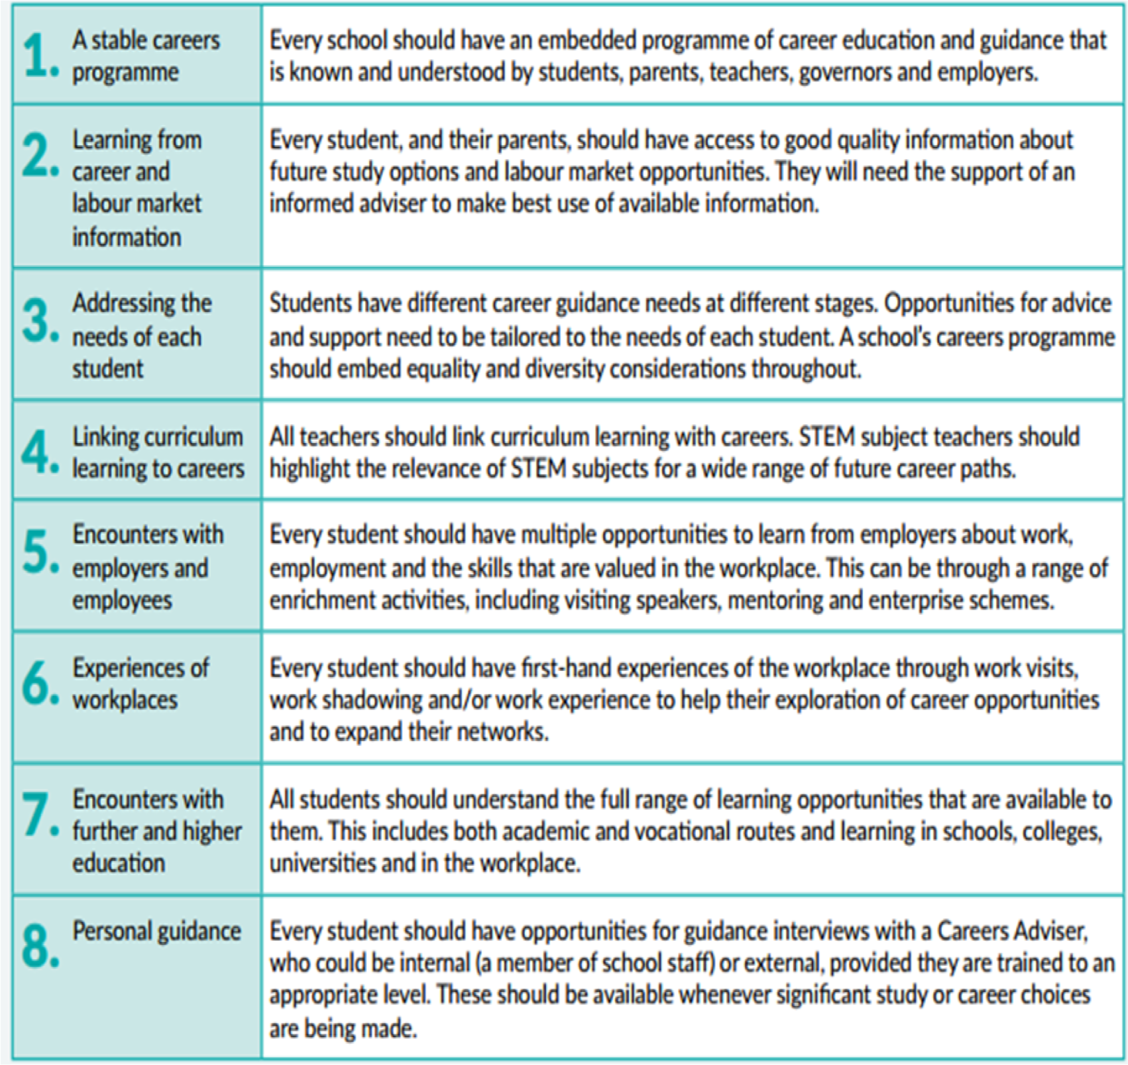
THE GATSBY BENCHMARKS
The Gatsby Benchmarks set out a framework for schools to deliver ‘good careers guidance’ to their pupils. The eight benchmarks are a framework for good career guidance developed by the Gatsby Foundation to support schools in providing students with the best possible careers education, information, advice, and guidance.

THE CAREER DEVELOPMENT INSTITUTE (CDI)
Framework for careers, employability and enterprise education

The framework presents learning outcome statements across 17 important areas of careers, learning and enterprise education grouped under three headings.

Developing yourself through careers, employability and enterprise education

1 Self-awareness
2 Self-determination
3 Self-improvement as a learner

Learning about careers and the world of work

4 Exploring careers and career development
5 Investigating work and working life
6 Understanding business and working life
7 Investigating jobs and labour market information (LMI)
8 Valuing equality, diversity and inclusion
9 Learning about safe working practices and environments

Developing your career management and employability skills

10 Making the most of careers information, advice and guidance
11 Preparing for employability
12 Showing initiative and enterprise
13 Developing personal financial capability
14 Identifying choices and opportunities
15 Planning and deciding
16 Handling applications and interviews
17 Managing changes and transitions

