What is the East Midlands Enterprise Gateway?
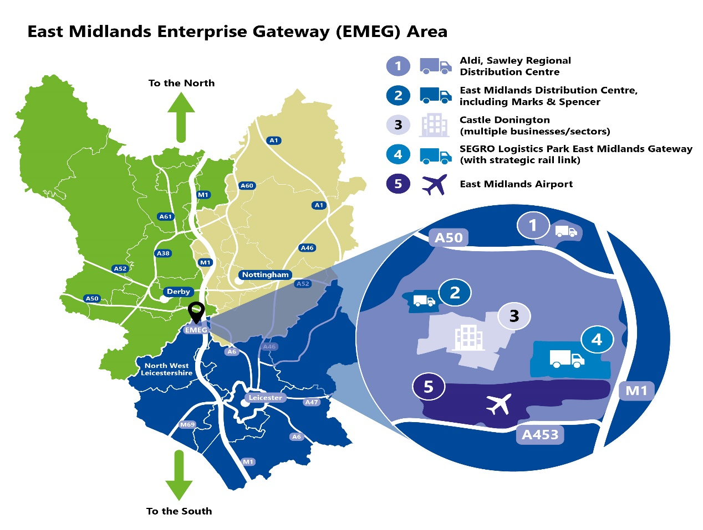
EMEG stands for East Midlands Enterprise Gateway, which covers a booming area of industry and jobs around Castle Donington in North West Leicestershire, and next to the borders of Derbyshire and Nottinghamshire.

EMEG covers five key sites and the area around East Midlands Airport; Donington Park; Castle Donington, Lockington & Hemington – including East Midlands Distribution Centre; Trent Lane Industrial Estate; Willow Farm; and SEGRO Logistics Park East Midlands Gateway. All are well connected to the transport network, and Aldi’s Regional Distribution Centre is nearby.

- A great career starts here - why is the EMEG area a fantastic place for jobs?
EMEG covers a huge area where there are a wide range of careers and opportunities for people. As online retail booms, and customers need goods faster than ever before, there are plenty of opportunities to do interesting work across a range of companies in different sectors. The area has above average* area apprenticeship starts, and job vacancies advertised.

- What does EMEG mean for me?
Whether you are starting out in your career, returning to work or a looking for a new job, there is something for everyone. Employers welcome all ages! With a broad range of roles, there are opportunities for people at all levels, with access to on-the-job training, progression, and perks.

- About the EMEG
At the centre of EMEG is the SEGRO Logistics Park East Midlands Gateway, - a 700-acre development, with plans for up to 6,000,000sq ft of logistics accommodation. SEGRO incorporates a 50-acre Strategic Rail Freight Interchange, connecting it to road, rail and air transport networks. It is home to companies such as Amazon; The Very Group; GXO (operating on behalf of Nestle); Kuehne & Nagel; Games Workshop and Maritime Transport. In 2022 a large facility will open for Mars, which will be operated by DHL. When fully occupied it is anticipated that the Park will employ approximately 7,000 people.

Another area of EMEG is East Midlands Distribution Centre – a nationally recognised Distribution Park, dominated by the one-million square foot e-commence distribution centre for Marks and Spencer. It is also home to a variety of companies including Moran Logistics; Redrow; Birlea; Klober and Interlevin.

The Aldi Regional Distribution Centre, on the A50, is also part of EMEG, which opened in March 2020 and employs hundreds of staff, supplying over 80 of its stores across the East Midlands.

East Midlands Airport is home to the UK's largest express air freight operation, handling 440,000 tonnes of cargo per year and generating millions for the region annually. The airport is the UK hub for DHL and UPS and supports Amazon, FedEx, and Royal Mail operations. There are over 100 different job roles across the site, supporting both passenger and cargo services. Roles include baggage handlers, customs staff, retail staff, freight forwarders and customer advisors, to name a few.

Across Castle Donington, there are several manufacturing employers like DPI (UK), Belfield, F C Cartons, Charles Blyth; Hypnos, Homag, Illuma and Gordon-Ellis. House builder Redrow has its main offices on EMDC and other commercial and professional organisations have a presence including PwC; National grid, Western Power; Cameron Homes, Cooper Parry Wealth and HSBC (Business Banking) service industry providers and other employers like the renowned Donington Park; MotorSport Vision (MSV), owners of the racing circuit, plan to develop the nearby Donington Hall Estate into a luxury racing themed 40-bedroom hotel by the 2023 season. There are also a wealth of other hotels serving both East Midlands Airport and local businesses. Being centrally located, they are ideally placed for business and leisure meet ups.

In addition, many employers will have wider job roles such as IT support, customer services, HR, digital roles, marketing, and sales.

- How do I get to EMEG?
EMEG is easily accessible from Leicestershire, Derbyshire and Nottinghamshire. The area is well served by both main highways – M1/A42/A50 as well as by frequent bus services from the three city centres of Leicester, Nottingham and Derby and other local towns.

- How can I find out more about EMEG jobs?
If you are at school or college, you can talk to your career’s adviser there. You can also look at the National Apprenticeship website www.gov.uk/apply-apprenticeship, or approach employers direct, look at their websites, and see the careers sites for East Midlands Airport and East Midlands Gateway (slp-emg.com). There are also regular job fairs advertised for the area organised by North West Leicestershire District Council. In addition, if you are unemployed, your local Job Centre can help.

In future there are even more jobs coming to the area!
An East Midlands Freeport has recently been endorsed by the Government, which covers part of EMEG in Leicestershire, and parts of Nottinghamshire and Derbyshire. Goods that arrive into freeports from abroad aren't subject to the tax charges, called tariffs, normally paid to the government, which should attract more employers to the area, driving further growth and jobs. Find out more on the LLEP website.

*Source EMSI and LSR online, North West Leicestershire performed above average for advertised jobs and apprenticeships across the Leicestershire area in 2021. This resource summary was created by Anna Cyhan (LLEP) and Heather Bell (NWL DC) with multiple EMEG partners to help to raise awareness of opportunities across the five sites.

