Leicester and Leicestershire Enterprise Partnership (LLEP) Communications Outsourcing Specification for Social Media

Frequently Asked Questions

We have received several questions regarding the tender documents and specifications. Below are our responses.

- Please confirm the volume of content for social media. There’s also a requirement for Video asset creation – please provide more details about this.

On average, the LLEP posts 2-4 scheduled tweets a day (up to 20 posts Mon-Fri). These cover a selection of current topics/key messages and include a couple of evergreen posts a week about what the LLEP is and does.

Based on the information in the specification for LLEP Social media campaigns, the split could be:

1. A suite of evergreen posts about who the LLEP is and what we do (2 posts per week on a 3 week cycle)
2. Some specific content Posts around our Strategies, Investments and Programmes – for example – 10 Years of LLEP/Sector Profiles/Economic Growth Strategy/Apprenticeship Strategy – up to 16 social posts a week.
3. Posts for newsletter signups/subscribe for updates (2 posts per week on a 3 week cycle)
4. Posts for events and webinars (as needed) The LLEP does not run regular events so 1-2 posts a day needed to promote the event effectively when an event is planned.

LLEP posts on LinkedIn – these are related to when we have something new to say. LinkedIn posts are related to LLEP news on the website or new Twitter content. 2 or 3 posts per week would be good.

Instagram as per LinkedIn 2-3 posts a week but need to be visually engaging.

Regarding video assets – we would want 15-30 second videos created. As a guide the following campaign is the biggest and requires content for:

15 Sector Profiles – each profile will need 3 x 20 second videos to reflect the headline information – see example below for Low Carbon Sector. We want to get the six facts in the infographic into a short social media video to share.

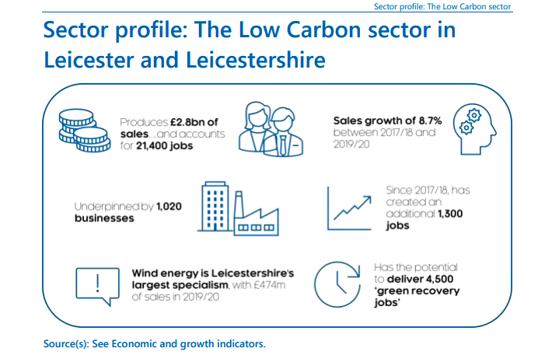

For the Economic Growth Strategy/Apprenticeship Strategy we would need 2 x 15 second videos for each plus static image posts creating.

The Careers Hub Twitter account would require 2 posts per day.

- Please clarify the value of each specification.

Each specification is a separate requirement and has a maximum budget of £19,999 which is the maximum amount we are allowed to procure without going through a formal full tender process. We are not expecting quotes to be near this value and in order to submit a competitive tender, applicants should keep prices realistic.

- There is only one application form – QRF LLEP Communications Outsourcing 2021-22?

Each specification requires a separate QRF form. If you wish to tender for all 3 specifications you will need to submit 3 QRF forms.

